Economic Cooperation Organization (ECO),
UNted NAtions STATISTICS DIVISION(UNSD)
AND
Statistical Centre of Iran (SCI)

Training Workshop on the Implementation of the System of National Account 2008]

14-17 October 2012, Tehran, Islamic Republic of Iran

INFORMATION NOTE FOR OVERSEAS PARTICIPANTS

- Workshop-related Information

Venue and opening session

- The Training Workshop on the Implementation of the System of National Account 2008, organized by the Economic Cooperation Organization (ECO) and the Statistical Centre of Iran (SCI) of the Government of the Islamic Republic of Iran in collaboration with the United Nations Statistics Division (UNSD), will be conducted from Sunday, 14 to Wednesday, 17 October 2012 at the Statistical Research and Training Centre.

Statistical Research and Training Centre (SRTC)
No. 5, East 25th St.
Yousef Abad, Asad Abadi St. Vali-e-Asr Ave.
Tehran, Islamic Republic of Iran
Phone: +98 21 88725153-4, 88725111-2
Fax: +98 21 88725153-4
E-mail: naghikhani.m@gmail.com &srtc@srtc.ac.ir,

- The opening ceremony for the Workshop will be held at 09:00 a.m on Sunday,14 October 2012 at the classroom of the Statistical Research and Training Centre.

Registration and identification badges

- All participants are requested to register at the Registration Desk located in the lobby close to the Classroom at 08:30 – 09:00 a.m on the same day. Name badges will be issued upon registration and they are to be worn during the Workshop.

- Name badges will be issued upon registration and they are to be worn during the workshop. Training sessions will be conducted at the classroom on the first floor of SRTC.

Working languages of the Workshop

- The workshop will be conducted in English and all documentation will be in English. However, interpretation services into Russian will be provided by the ECO Secretariat.

Contacts of ECO and Workshop Coordinators

- For any information regarding the workshop, participants may contact ECO focal person as follows:

Mr. Mohammad Hosein Amini
Program Officer
Directorate for Project and Economic Research and Statistics (PERS)
Economic Cooperation Organization (ECO)
No. 1, Golbou Alley, Kamranieh St. , Tehran , Iran
Postal Code: 19519 - 33114
Tel: (+98-21) 22 83 17 33 - 4
Fax: (+98-21) 22 83 17 32
Mobile: (+98) 912- 322 31 59
E-mail: po.pers@ecosecretariat.org
Website: www.ecosecretariat.org

- For local logistics arrangements, participants may contact the Workshop Coordinators of SCI as follows:

Name: Mr. Farshad Golestan
Functional title: In-charge
Division Name: Office of the Head, Public Relations and InternationalCooperation,
Statistical Centre of Iran
Address: Dr. Fatemi Ave. Tehran, 1414663111,Islamic Republic of Iran
Phone: 0098 21 88958189, 0098 21 88964472 ( from Saturday to
Wedensday )
Fax: 0098 21 88958189, 0098 21 88964472
Mobile: 0098 9122972184( Ms. Faghih), 0098 9358240975(Mr. Maleki)
e-mail: int@sci.org.ir , ati.khoshabi@yahoo.com & ali.maleki.a@gmail.com

- To facilitate the local logistics arrangements, participants are requested to complete and send the “Attendance Information Form” at Attachment 2 as soon as possible, but no later than 23 September 2012, to the Workshop Coordinator with copy to the focal person of ECO.

II. Travel and Accommodation Arrangements

Travel arrangements

- The Economic Cooperation Organization (ECO) will provide participants of Member States (only one participant from each member state) with the most direct economy air ticket to travel from the country of their residence to Imam Khomeini International Airport (IKIA) in Tehran and return. Participants are required to book a flight and purchase their ticket and their airfare will be reimbursed by the ECO subject to its pertinent rules and regulations. Arrangements should be made by the participants in a manner that to enable them to arrive in Tehran, on Saturday, 13 October 2012 and depart for their respective countries on Thursday, 18 October 2012.

- Any questions regarding international travel arrangements as well as any additional queries could be addressed to the focal person of ECO in the Secretariat.

Accommodation and meals

- Accommodation for 5 nights (from 13 October to 18 October 2012) and meals during the workshop (from 14 October to 17 October 2012) will be provided by the SCI for all overseas participants. All overseas participants will stay at the SCI Guest House. Guide map of SCI Guest House is provided in Attachment 1.

SCI Guest House
No. 5, East 25th St.
Yousef Abad, Asad Abadi St. Vali-e-Asr Ave.
Tehran, Islamic Republic of Iran

Phone:0098 21 88725089& 88725101
Fax: 0098 21 88725089
e-mail: int@sci.org.ir , ati.khoshabi@yahoo.com & ali.maleki.a@gmail.com

Daily Subsistence Allowance (DSA)

- Since accommodation and meals will be provided by the SCI, there will be no DSA payment for the Workshop participants

- Participants are requested to bring their passports, air tickets and inbound boarding passes with them to the Workshop venue on the first day of the training (14 October 2012).

- ECO or SCI will not assume responsibility for any other expenditures, such as:
- Salary and related allowances for participants during the period of the Workshop;
- Costs incurred by participants in respect of travel insurance, accident insurance, medical or dental bills or hospitalization fees in connection with their attending the Workshop;
- Compensation in the event of death or disability of participants in connection with their attending the Workshop;
- Any loss or damage to personal property of participants while attending the Workshop or losses or damages claimed by third parties as a result of negligence on the part of the participants; and
- Any other expenses.

Visa requirements

- Participants are urged to fill in the attached “INFORMATION SHEET FOR IRAN ENTRY VISA APPLICATION (Form D)” and send the completed form to Mr. Farshad Golestan or Ms. Atiyeh Faghih of SCI (email address: int@sci.org.ir, ati.khoshabi@yahoo.com, ali.maleki.a@gmail.com) as soon as possible but no later than 23 September 2012 for timely arrangements for issuing their Iran entry visa application.

- Participants are also urged to apply for appropriate entry visa at the relevant diplomatic or consular mission of the Government of the Islamic Republic of Iran as soon as they receive the Iranian Ministry of Foreign Affairs’ Confirmation No. provided by the SCI. Since the processing of visa issuance will take considerable time, participants must pay priority attention to this matter.

Local transport

- Upon arrival at the Imam Khomeini International Airport (IKIA) in Tehran, participants will be met by staff of SCI accompanying a picket stating "ECO/SCI". Transportation from the airport to SCI Guest House and from SCI Guest House to the airport will be provided by SCI.

Restrictions

- To ascertain participants would devote full attention on the training, the ECO does not permit participants to bring family member(s) with them to Tehran, Islamic Republic of Iran.

III. Other Arrangements/Information

- Reconfirmation of Return Flights -- Participants will be assisted by the SCI staff in making reconfirmation of their return flights; their passports and tickets will be collected on 15 October 2012 ( the second day of the workshop) for this purpose. All participants are urged to refrain from changing official itinerary arranged by the ECO.

Foreign Exchange – The local banks in Tehran provide foreign currency exchange service. The current exchange rate in Iranian banking system is approx. Rials 12284 to one US Dollar. The exchange services are also available through exchange offices in the city whose exchange rates are higher than banks (approx. Rials 24000 to one US Dollar). Participants are advised to carry sufficient amount of funds and to convert them to local currencies for transportation expenses at transit point(s) and upon arrival in Tehran. Foreign exchange facilities are available 24 hours at the Airport.

- Weather and Clothing – The weather in Tehran in mid October will be mild. The average temperature ranges from 14 to 24 degrees Centigrade. Warm clothing would suffice. All female participants are kindly requested to observe appropriate Islamic dress code (e.g. scarf for covering their hair, pants and thigh-long dress with long-sleeves).

- Electricity voltage -- The voltage for all electric appliances used in the Islamic Republic of Iran is 220 Volts.

- Food preference – Meals will be provided at the dining room of the Guest House. Participants who have dietary restrictions, are strongly encouraged to inform the SCI to observe their restrictions.

- Further supplementary information will be provided on the first day of the workshop.

* * *
Attachment 1
Map and full address of the SCI guest house

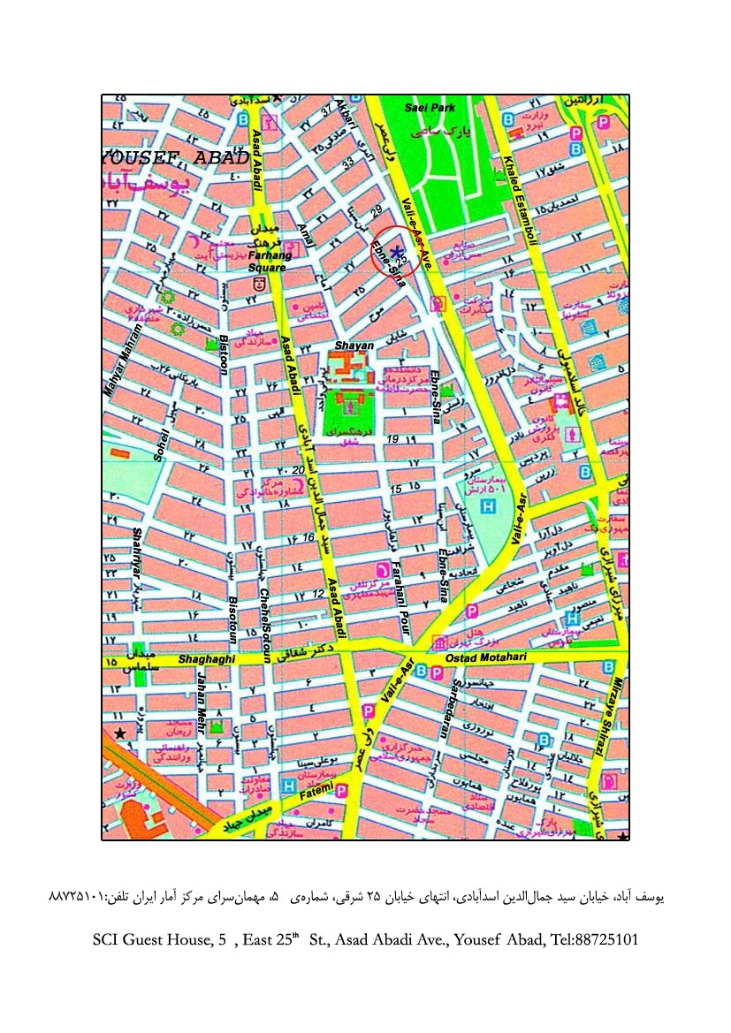

Attachment 2

Training Workshop on the Implementation of the System of National Account 2008]

14-17 October 2012, Tehran, Islamic Republic of Iran

ATTENDANCE INFORMATION FORM
(Please type or print)
- GIVEN NAME: ___________________________________________________

- FAMILY NAME: ___________________________________________________

- SEX: ___________________________________________________

- FUNCTIONAL TITLE: ___________________________________________________

- ORGANIZATION: _________________________________________________

- OFFICIAL MAILING ADDRESS: _____________________________________

________________________________________________________________________

Phone: _____________ Fax: _______________ E-mail: _____________

- ARRIVAL IN tehran:
Date: ___________ Flight number: ____________ Time of arrival: ___________

- DEPARTURE DATE

Date: ___________ Flight number: ___________ Time of departure: _________

Please send this attendance information to:
Mr. Farshad Golestan  In-charge  Office of the Head, Public Relations and International Cooperation, Statistical Centre of Iran  Dr. Fatemi Ave. Tehran, 1414663111,Islamic Republic of Iran  Fax: 0098 21 88958189, 0098 21 88964472( from Saturday to Wedensday )  e-mail: int@sci.org.ir , ati.khoshabi@yahoo.com & ali.maleki.a@gmail.com | with copy to:  Mr. Mohammad Hosein Amini  Program Officer  Directorate for Project and Economic Research and Statistics (PERS)  Economic Cooperation Organization (ECO)  No. 1, Golbou Alley, Kamranieh St. , Tehran , Iran  Postal Code: 19519 - 33114  Tel: (+98-21) 22 83 17 33 - 4  Fax: (+98-21) 22 83 17 32  Mobile: (+98) 912- 322 31 59  E-mail: po.pers@ecosecretariat.org  Website: www.ecosecretariat.org

